**Experimental Bump Test and Model Validation**

Charles Keer and Marielle Lenehan*

Experiment 1: Servo Modeling

TA: Stephen Brutch

Section: 09DB

7 October 2023



Embry-Riddle Aeronautical University

1 Aerospace Boulevard

Daytona Beach, FL 32114

Table of Contents

Table of Contents 2

Table of Figures **Error! Bookmark not defined.**

Table of Tables **Error! Bookmark not defined.**

1. Abstract 3

2. Procedure 3

2.1 Bump Test Experiment 3

2.2 Model Validation 3

3. Results 4

3.1 Calculations 4

3.2 Response Plots 5

3.3 Additional Data Collected 7

4. Analysis 7

5. Conclusions 8

6. References 8

1. Abstract

Mathematical modeling of real-world systems can prove to be a challenging endeavor. Using classical control problems, this report will demonstrate the modeling of a servo motor using an experimental bump test. A transfer function was found and subsequently tuned using the servo as validation. The results of this experiment are presented in this paper.

1. Procedure
   1. Bump Test Experiment

A bump test was utilized on the servo motor to find a transfer function of the system. This is done by briefly perturbing the system or “bumping” it and analyzing the response of the servo motor versus the input voltage. For this experiment to work, the system needs to be stable.

The bump test was conducted in accordance with the accompanying lab manual. After the servo motor was connected to the data acquisition device (DAQ), encoders, and amplifiers, the MATLAB script and Simulink model signal generation block was updated to reflect the necessary conditions for operation:

Table 1. Bump Test Experimental Parameters

|  |  |
| --- | --- |
| **Parameter** | **Value** |
| Waveform Type | Square |
| Signal Generator Amplitude | 1.0 (V) |
| Signal Generator Frequency | 0.4 (Hz) |
| Simulink Speed Constant | 2 |
| Amplitude Gain | 1.5 (V) |
| Voltage Offset | 2.0 (V) |

Once completed, the load shaft speed scope and motor voltage input scope were opened. “Run” was clicked on the Simulink model and the servo began to “bump”. Once a few waveforms were recorded, “Stop” was clicked and the data from the Bump Test from the servo shaft response and motor voltage was saved. Using the data, the steady state gain and time constant of the system was found and recorded.

* 1. Model Validation

This experiment was performed in the same manner as the Bump Test. However, different values for “K” and “τ” were input and their data recorded. The setup parameters for the Model Validation experiment can be seen in Table 2:

Table 2. Model Validation Experimental Parameters

|  |  |
| --- | --- |
| **Parameter** | **Value** |
| Waveform Type | Square |
| Signal Generator Amplitude | 1.0 (V) |
| Signal Generator Frequency | 0.4 (Hz) |
| Simulink Speed Constant | 2 |
| Amplitude Gain | 1.0 (V) |
| Voltage Offset | 1.5 (V) |

Four tests were conducted for this experiment. The first changed the values of “K” and “τ” to 0.8 and 0.06 respectively. The second test saw “K” and “τ” changed to 1.25 and 0.2 respectively. The third test set “K” and “τ” to 1.53 and 0.0253, which were the calculated nominal values for the system. The fourth and final test for this experiment was to find the “best fit” for the response of the system to the motor voltage input. “K” and “τ” were modified until the response matched the input.

1. Results
   1. Calculations

Calculating the real-world gain “K” can be found as:

$K=\frac{∆ω_{l}}{∆V_{m}}= \frac{5.90879-0.61113}{3.5-3}=1.77\frac{rad}{V*sec}$ (1)

Where Equation 1 is the difference in the rise time of the servo response over the change in motor voltage. This is derived from Equation 30 in the lab manual. Similarly, the time constant can be calculated from 60% of the rise time in the system as shown:

$τ=t_{1}-t_{0}=1.284-1.253=0.031$ (2)

This time constant equation was also taken from Equation 33 in the lab manual. Finally, using both the real-world gain and time constant and utilizing Equation 29 from the lab manual, the real-world transfer function can be obtained:

(3)

* 1. 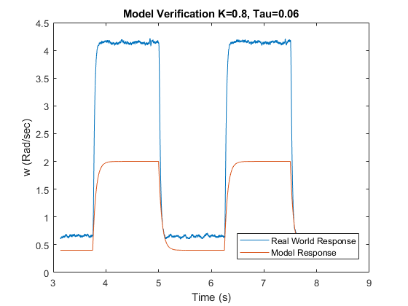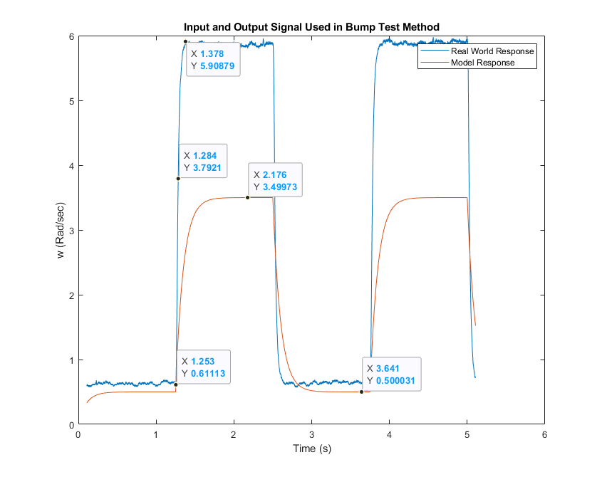Response Plots

Figure 2. Model Verification Experiment #1

Figure 1. Bump Test Results and Calculation Values

Figure 4. Model Validation Experiment #3. Nominal Values.

Figure 3. Model Validation Experiment #2

Figure 1. Model Validation Test #4. Tuned Values.

* 1. Additional Data Collected

Table 3. Additional Data Collected

|  |  |  |  |
| --- | --- | --- | --- |
| Section | Description | Symbol | Value |
| 1.2 | **Nominal Values**  Open-Loop Steady-State Gain  Open-Loop Time Constant | K  τ | 1.53  0.0253 |
| 1.3.2 | **Bump Test**  Open-Loop Steady-State Gain  Open-Loop Time Constant | K  τ | 0.57  0.134 |
| 1.3.2 | **Model Validation**  Open-Loop Steady-State Gain  Open-Loop Time Constant | K  τ | 1.66  0.0253 |

1. Analysis

The nominal values for the system were provided to us during the lab, which is why they differed from the calculated values seen in equations 1-3. Modifying the gain and time constants had significant effects on the model’s response to the input voltage. The higher the gain, the more closely the output speed would match the model. Similarly, the lower the time constant, the faster the rising and falling edge response would be, changing the overall damping of the system. Once the correct gain and time constant values were found, the model matched the actual system reasonably well. These values for the tuned system were 1.66 for the gain, and 0.0253 for the time constant. There will always be some noise in the system which is why the real-world model does not have a perfectly straight steady state response. However, the average overall response matches, which establishes confidence in the model provided.

1. Conclusions

By utilizing a bump test, the real-world time constant and gain could be calculated for the servo system and then transferred to a model. By varying the model to tune these variables, a good approximation for the real-world response was created. This was validated in the second, model validation experiment, through the data shown in this paper. Overall, this experiment was successful in illustrating how to transfer a real-world system into a model and tune that model for optimal results.

While this modeling technique is rather accurate, it is important to remember that real-world devices are imperfect and can carry errors throughout calculations. For example, in the servo system, the gear meshing is not perfect and the model for the gears is only an estimate of how they function. Friction needs to also be considered as well as the sampling rates and accuracy of the amplifiers and encoders. For what this lab was trying to demonstrate, however, this can reasonably be negligible.

1. References

Quanser Student Workbook Experiment 01 – Quanser